 | RAS6083  IAEA/RCA Regional Training Course on Theragnostics and Dementias  December 4-8, 2017  Osaka University Graduate School of Medicine, Osaka, Japan  Application Form | 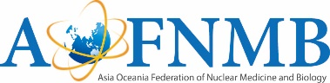
1) Personal Information
(*) First Name
Middle Name (if available)
(*) Last Name (Family Name)
Gender | □ Male □ Female
(*) Nationality
(*) Institute
Department
(*) Title | □ Prof. □ Dr. □ Ms. □ Mr. □ Other: ( )
Occupation | □ MD □Technologist □Chemist □ Other: ( )
AOFNMB membership | □ Member (ID )*necessary
* This information will be printed on the name badge. Please fill all items correctly.

2) If you need documents for VISA application, please input below
Full Name (same as passport)
Passport number
Date of Birth (YYYY/MM/DD)
Postal address for visa documents delivery | □ Office □ Home
Country
Phone Number (please include country code)
Email address
Date of arrival in Japan
Date of departure from Japan
** Please attach the copy of your passport.
* Please return this form before the deadline: November 20, 2017.
* For any inquiries, please contact: aofnmb.osaka@gmail.com

